Practical Documentation

GlobalX Coding Assessment

Submitted by

Sipon Hossain
Sipon.here@gmail.com

Table of Contents
1. Introduction 2
2. Assessment Specification 3
3. Class Diagram 3
4. Source Code 3
5. User Manual 4
6. Test 7
7. Conclusion 8

Introduction

The GlobalX Coding assessment is an assessment. This assessment is included a simple problem. The main objective of the assessment is to solve the problem easy way and ability to compose quality code that address to SOLID principle.

Assessment Specification
The assessment must meet the following requirements:
- Build a name sorter
- Given a set of names where order set first by last name.
- A person name must have at least 1 and may up to 3 given names.
- Given name a file will be unsorted-names-list where contain a list of name
- The program will execute in the format: name-sorter ./unsorted-names-list.txt
- The result will show in the screen according to the given sorted name and directory file will be sorted-names-list.
- The solution should be capable to execute a list with thousand names.
- The solution should exist a unit test.

Class Diagram
The following diagram is illustrated how the problem solved using the classes, attributes, interfaces and methods.

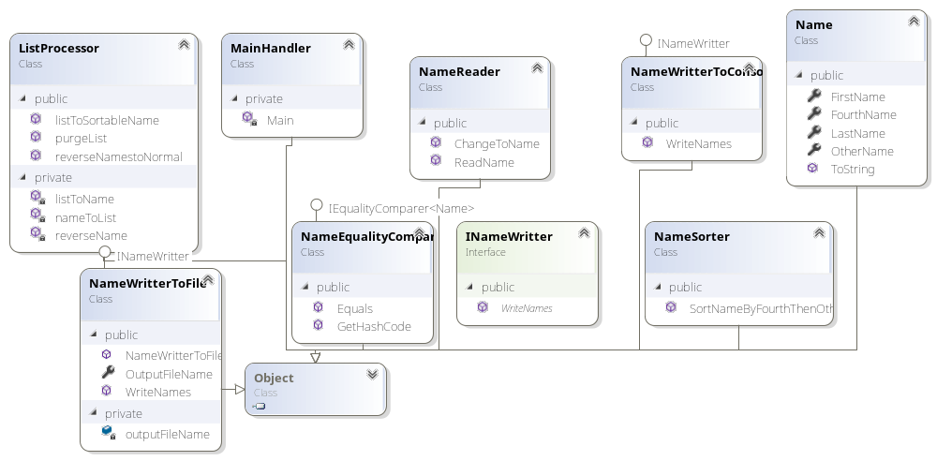

Source Code

The assessment source code is provided on the following Github repository link:
https://github.com/bdsipon/Name-Sorter

User Manual
The user manual demonstrated how the program runs in your computer.
Step1: Click the link (https://github.com/bdsipon/Name-Sorter)
Step2: Build your own version using Visual Studio 2017. We have two options to open the files either download the source code or git clone.
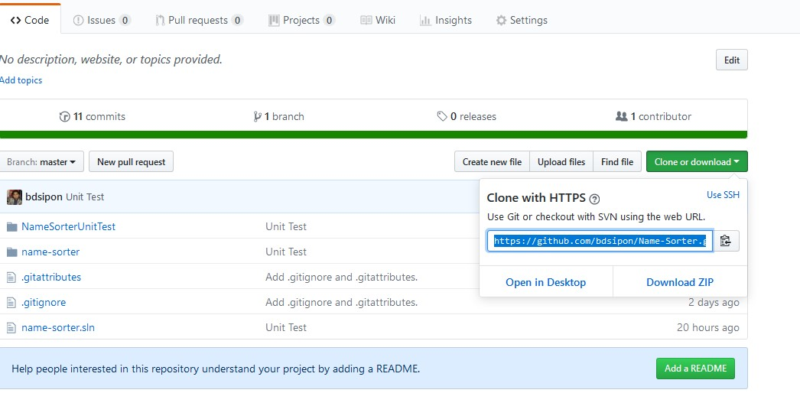
Step 3: Build Solution.
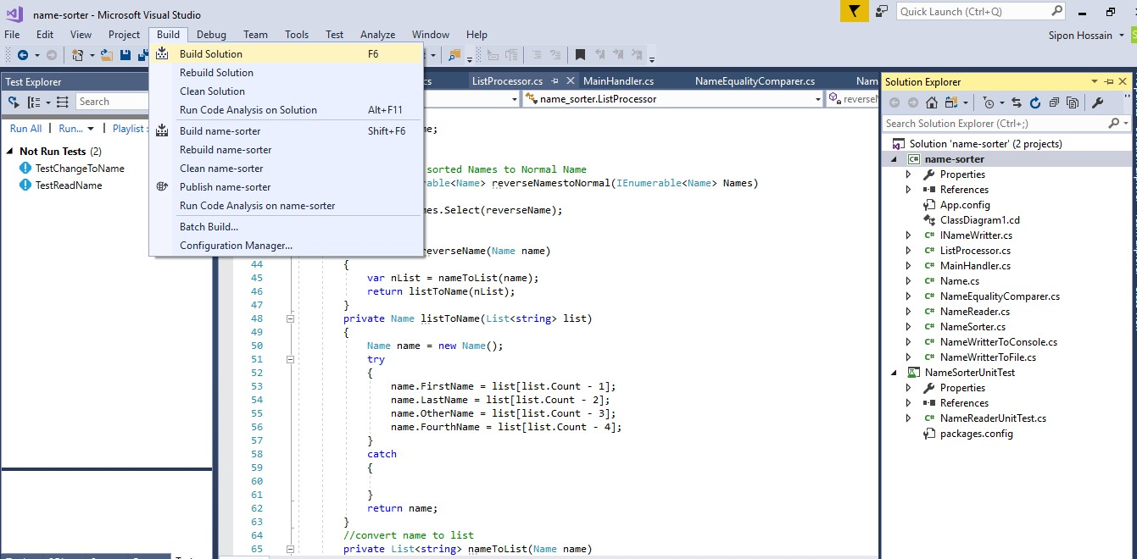
Step4: When succeed the build. Right click open the name-sorter and go to file explorer.
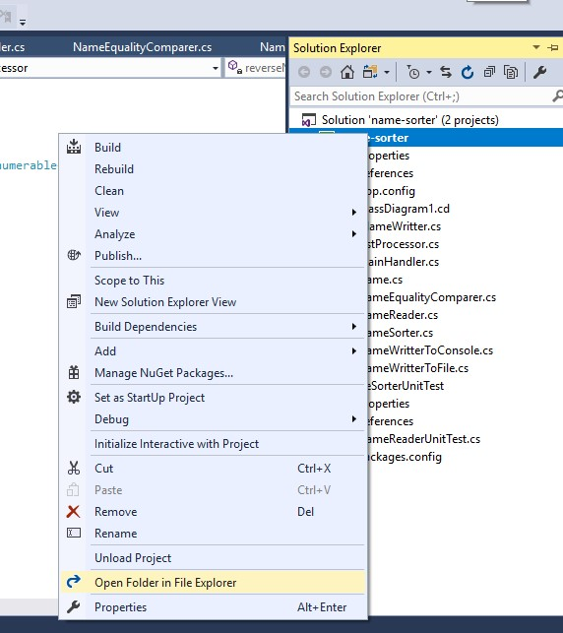

Step5: Click the bin folder and go to debug
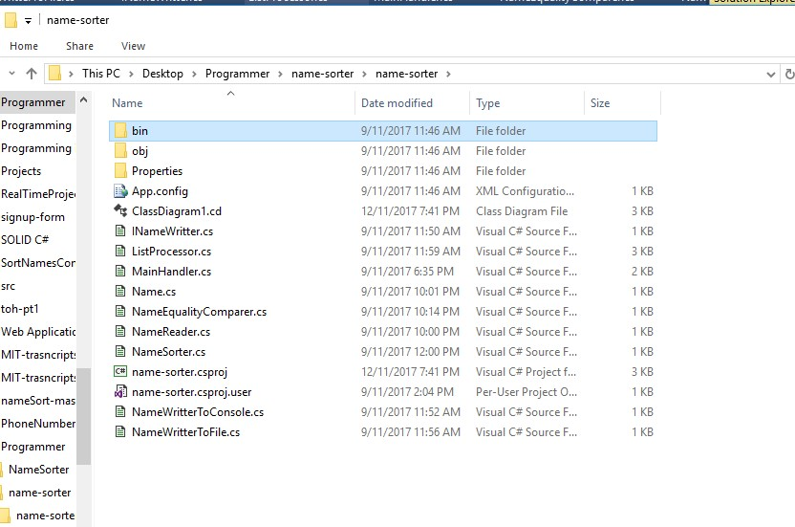
Step6: Copy the link and open the command line and go to the folder.
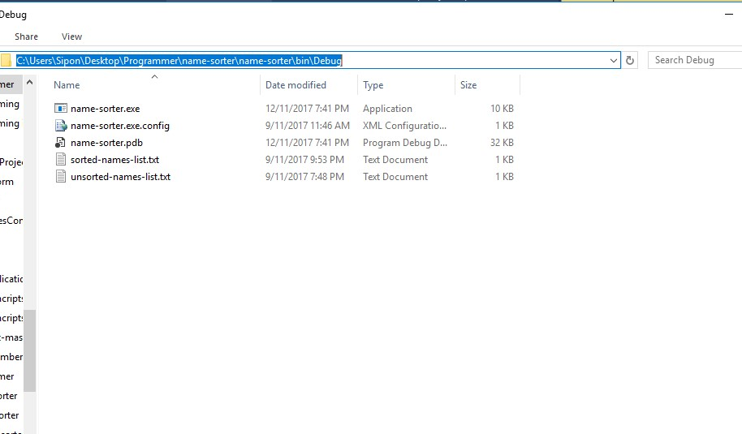

Step7: Finally run the program according to the instruction (name-sorter ./unsorted-names-list.txt)
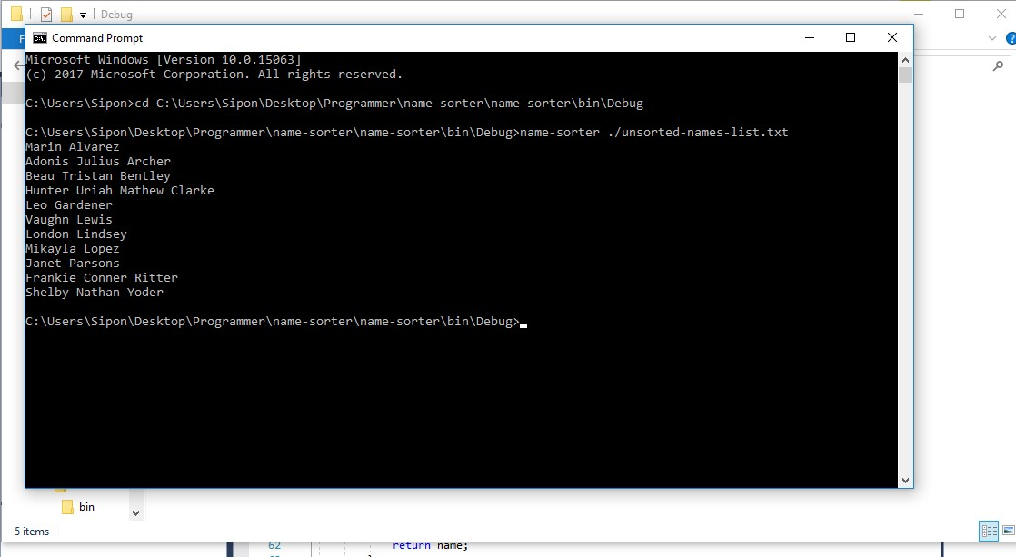

Step8: Successfully run the project. Go to the debug folder and find out the sorted-names-list.txt file.

Test
Testing is the vital part of software development. The assessment is used unit test which individual components are tested. The following figure demonstrated this program successfully done the testing.
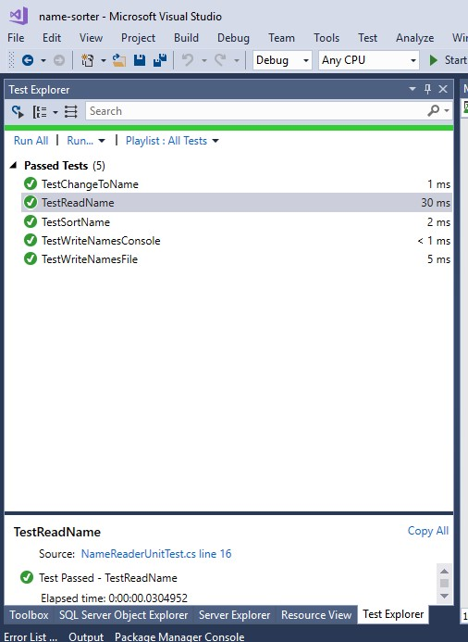

Conclusion

The documentation described about Globalx Coding assignment which included assessment specification, Class diagram, source code, user manual and the unit test.

